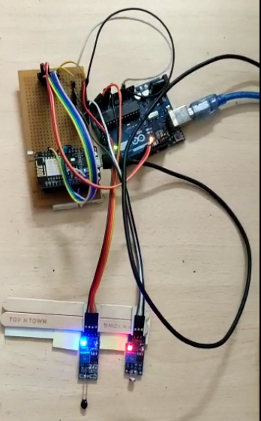 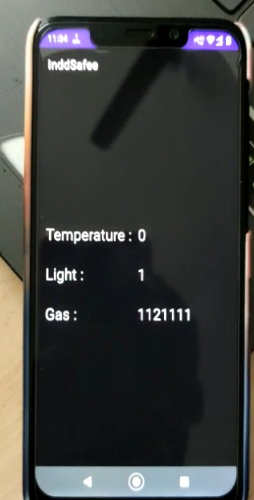

Test Setup Real Time Reading of App(LDR OFF)

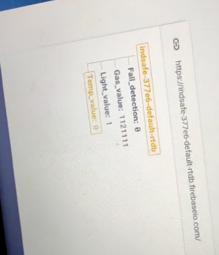

Reading of firebase(LDR OFF,Light_value - 1)

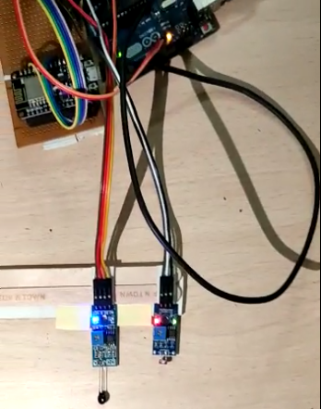 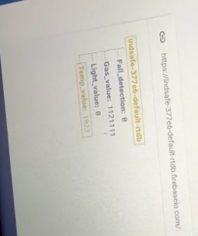

LDR Sensor ON Reading in Firebase(LDR ON, Light_value - 0)

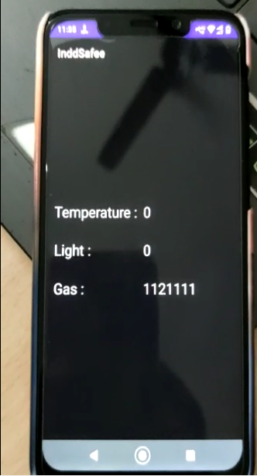

Real Time data on App